Chapter 13

Aggregate Scheduling

**Background**

As we move into Chapters 13-15 of the book, it becomes important for instructors to help the students see the big picture in terms of which techniques apply to which circumstances. Figure 13.1 (Slide 13-12) is quite useful in that regard. Chapter 12 just covered lot-sizing, but in Chapter 13 we are moving the planning horizon back out to the medium term. Different products that use similar resources are often “aggregated” to form an aggregate plan, and the focus here is on personnel planning decisions (including overtime), along with decisions regarding aggregate inventory levels and any needed use of subcontracting. The personnel decisions, in particular, may take time to implement, and, of course, they may impact workers’ lives positively or negatively.

Aggregate planning is really split into two parts: capacity options and demand options. Demand options are often implemented to smooth out the demand flow, which can make production planning much simpler and less costly. Yield management represents a somewhat extreme and very dynamic type of demand option. Usually, the capacity options are explored once the demand options have been determined and the demand pattern has been forecasted. A more comprehensive approach would be to try various demand options simultaneously with capacity options to find the best profit-producing mix. There is an obvious marketing component to this chapter, and it represents one of the best examples of how marketing can impact operations positively and negatively.

**Class Discussion Ideas**

1. Yield management (revenue management) has produced significant revenue gains for some firms. Some consumers extract a certain level of excitement by successfully locating or negotiating a particularly low price, but for others, yield management produces frustration. These customers often feel that they were charged more than necessary and that some other customers must be getting a better deal for the same service. Economics teaches us that a perfect pricing scheme would charge each customer exactly the maximum amount that he or she would be willing to pay, thus transferring all consumer surplus to the selling firm. However, consumers do not live in a vacuum, and in the real world, customers talk and reputation (good and bad) spreads. A class discussion could uncover students’ feelings about revenue management as consumers themselves. Do students like knowing that the airline price that they looked up an hour before might have changed already? Do they like playing a “wait and see” game until they think prices have hit rock bottom? Do any of them feel that they are treated unfairly? Discussion could turn to the ethics of price discrimination. Even if the practice is legal, is it ethical to treat consumers differently just because supply and demand conditions have changed? Should someone who reserved and paid for a spot on the cruise ship a year earlier have to pay twice as much as the last-minute vacationer who caught a discount price the day before the ship left? If given a choice, would any students select to purchase from a firm that did not price discriminate vs. one that did (or vice versa)?

2. A chase strategy often involves hiring and laying off workers regularly. The text mentions that the costs of hiring, layoff, and training may be significant. Class discussion could expand on this concept to explore the various human resource implications of such a strategy. What are some potential pitfalls, beyond the known direct hiring, layoff, and training costs, of a chase strategy? What potentially unforeseen worker-related issues might emerge? What human resource strategies might a firm implement to mitigate some of these potential risks?

**Active Classroom Learning Exercises**

1. Have the students split into small groups. Each group should choose a local organization and suggest how it might employ a level, chase, or mixed strategy to best meet demand. The students should be able to explain how their suggestion would enable the firm to best meet their typical demand in a way that minimizes cost or maximizes profit. Have each group share its findings with the class.

2. Table 13.5 from the text shows the comparisons from Examples 2, 3, and 4. For this problem, the subcontracting option performs best among those three choices. A fourth option performs even better—this is a combination of a level strategy (at 41 units per day) using inventory in the first three months and subcontracting in the last three months. Have the students determine the specific plan and compute the costs. (Inventory = 2, 40, and 101, for Jan., Feb., and Mar., respectively; and subcontracting = 238, 598, and 280, for Apr., May, and June, respectively. Total cost = $104,379.)

**Cinematic Ticklers**

1. *The Hudsucker Proxy: A Comedy of Invention (Tim Robbins, Jennifer Jason Leigh, Paul Newman), Warner Brothers Home Video, 1994*

During the introduction of the Hoola Hoop, we see a dramatic display of price discrimination as the store manager keeps reducing the price of this (apparently useless) toy all the way to zero until one kid figures out how to use it and every kid in town them demands one. A price premium is quickly introduced.

2. *Fawlty Towers*: *“Gourmet Night*” *(John Cleese and Prunella Scales), CBS/FOX VIDEO, 1986 (1975)*

The hotel owners try out a special weekly “gourmet night” at their restaurant in order to charge a premium to high-society guests and to keep the “riff-raff” out.

**Presentation Slides**

INTRODUCTION (13-1 through 13-8)

Slides 7-8: These slides summarize the Frito-Lay Global Company Profile. Slide 7: With a substantial level of capital investment, the plants must experience high utilization rates, and aggregate planning helps them attain those goals. Slide 8: The total demand profile considers several inputs, including historical sales (techniques of Chapter 4) but also information about new products, upcoming promotions from the marketing department, and input about local demand from local account managers.



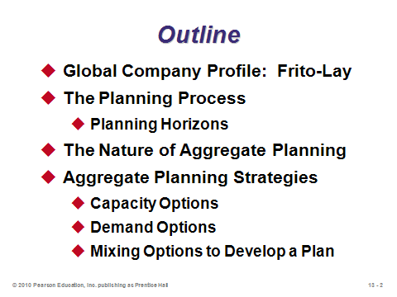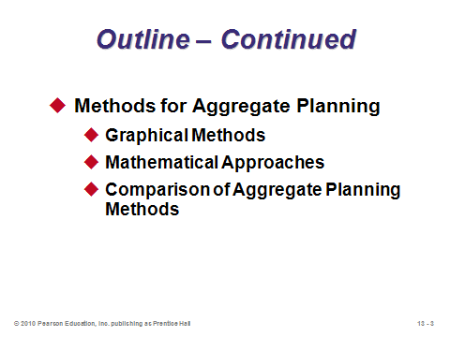

**13-1 13-2 13-3**

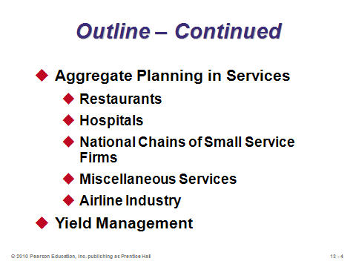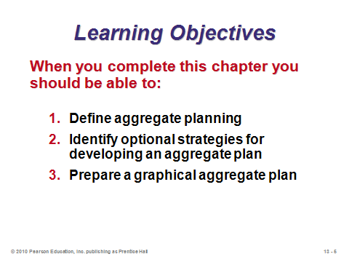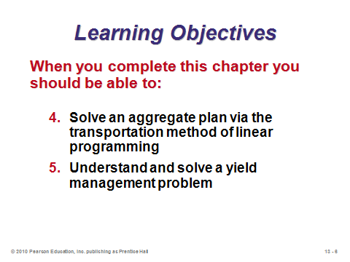

**13-4 13-5 13-6**

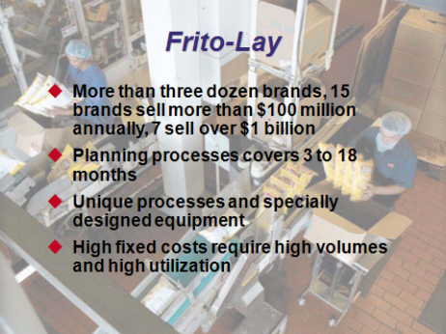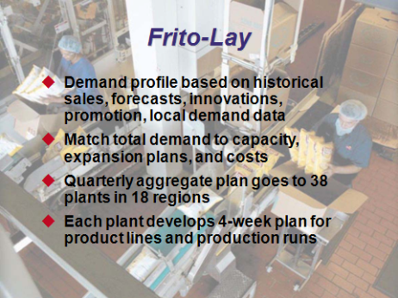

**13-7 13-8**

THE PLANNING PROCESS (13-9 through 13-12)

Slide 9: Aggregate planning covers intermediate-range decisions, usually 3 to 18 months ahead.

Slide 10: This slide provides the list of the major decisions undertaken in aggregate planning. Notice that scheduling of specific workers and products is *not* done in aggregate planning—such decisions represent short-term scheduling (Chapter 15) that will be based at the appropriate time on the constraints produced from the aggregate plan. The aggregate plan helps the firm prepare for any necessary hiring and layoffs of workers to come in the intermediate future. It also signals when to set up subcontracting relationships and orders.

Slide 11: This slide identifies the four things needed for aggregate planning.

Slide 12: This slide (Figure 13.1) helps to distinguish the various planning horizons and associated tasks and personnel responsible for the decisions. Aggregate planning provides the link between long-range capacity decisions (Supplement 7) and short-range scheduling of workers and jobs (Chapter 15). Long-range capacity decisions certainly impact the flexibility of aggregate plans.

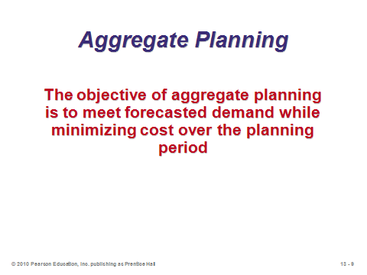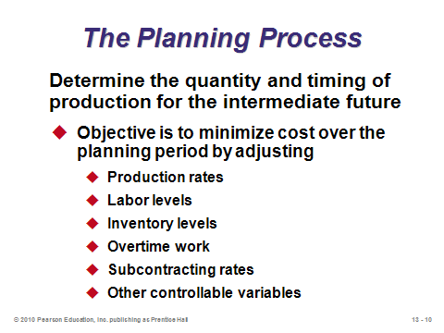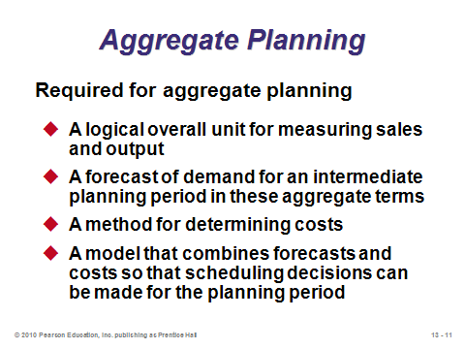

**13-9 13-10 13-11**

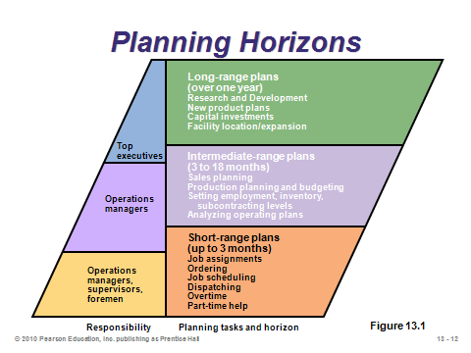

**13-12**

THE NATURE OF AGGREGATE PLANNING (13-13 through 13-15)

Slide 13: This example from the text shows a sample output of Snapper’s family of mowers for the upcoming three quarters. Typically in aggregate planning, the demand for different models is aggregated into a family for resource and production planning purposes.

Slide 14: This slide (Figure 13.2) shows how aggregate planning fits into the larger production planning system.

Slide 15: The aggregate plan is described in general terms. *Disaggregation* of the plan breaks it down into more detail for more specific planning such as the master production schedule, which is a timetable that specifies what is to be made and when (Chapter 14).

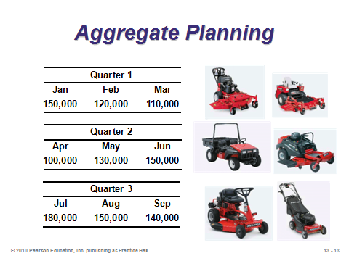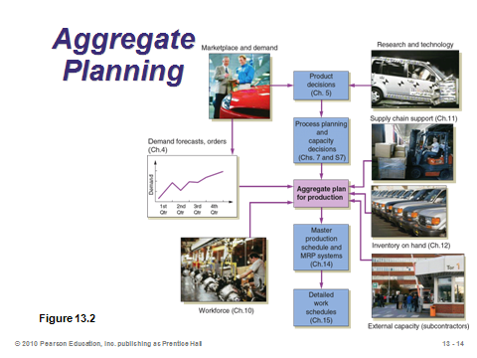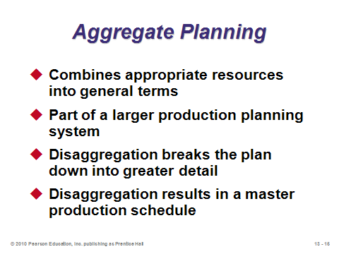

**13-13 13-14 13-15**

AGGREGATE PLANNING STRATEGIES (13-16 through 13-31)

Slide 16: This list presents legitimate planning strategies. The aggregate plan may suggest one or a combination of the strategies.

Slides 17-21: These slides describe the five *capacity options*, named so because they do not try to change demand but attempt to absorb demand fluctuations. Slide 17: firms can change inventory levels, building up *anticipatory inventory* during periods of low demand. We know from Chapter 12 that inventory is expensive, so this can be a costly approach for firms experiencing very seasonal demand. Slide 18: firms can vary the workforce size as demand conditions change. This strategy may work well if hiring and firing costs are not too high and significant training of new employees is not necessary. The human resource implications of this strategy need to be carefully considered. Slide 19: firms can vary production rates using overtime and idle time. This strategy may work well for short-term or relatively small demand changes, but it becomes expensive and potentially unmanageable for reacting to major demand shifts. Slide 20: firms can subcontract out excess demand that they cannot handle internally. The unit cost of this strategy is typically higher than the internal production cost, and the strategy carries with it the usually risks of delegating any task. Slide 21: firms can use temporary or part-time workers during peak demand periods. This practice may work well, particularly in service industries. However, there have been concerns in recent years that big companies are hiring too many temporary employees and avoiding paying benefits such as health insurance in the process. Concerns like this can damage a firm’s reputation as a good corporate citizen.

Slides 22-24: These slides cover *demand options*, through which firms try to smooth out changes in the demand pattern over the planning period. A smoother demand pattern implies less necessity for implementing one of the expensive capacity options. Instructors can present examples showing that sometimes a smooth demand pattern can result in higher overall profit than a varying pattern with higher total demand (i.e., the varying pattern might have more revenue but the additional costs of meeting that varying demand might outweigh the revenue gain). Slide 22: firms can influence demand through the use of advertising and promotions in low-demand periods. Such strategies are also known as *off-peak pricing*, and we see them all the time in the form of matinee movie specials, cheap rates at ski resorts during the summer, etc. Some of this generated demand may be new customers enticed by the promotion, but the rest may be *shifted* demand (customers moving from high-demand periods to low-demand periods). Shifted demand produces a smoother demand pattern overall. Slide 23: firms sometimes intentionally plan backorders during high-demand periods. These come at a cost and assume that customers will be willing to wait to receive the product (a potentially dangerous assumption). Firms with some sort of monopoly power are often in a better position to employ this strategy. Slide 24: firms sometimes employ the strategy of counterseasonal products and service mixing. Producing products with different high-demand seasons such as snowmobiles and jet skis can smooth out demand over the year. Another form of this technique sells seasonal products to markets in the Northern Hemisphere for part of the year and to markets in the Southern Hemisphere for the other part of the year.

Slides 25-28: These slides present Table 13.1 from the text, which nicely summarizes the pros and cons of each of the eight aggregate planning options. Instructors should point out the “Comments” column as well, which provides more information about the applicability of each option.

Slides 29-31: A combination of the different aggregate planning options may turn out to be the best strategy. There are also two extreme strategies: *chase* and *level*. Slide 30 describes the chase strategy, where demand is “chased” by production. Little or no inventory is held, and the strategy may result in a significant amount of hiring and worker layoffs. Slide 31 describes the level strategy, where workforce levels and production rates remain constant over time. The *changing inventory levels* option applies here. Human resource difficulties are usually minimized using a level strategy, but the inventory costs may be significant.

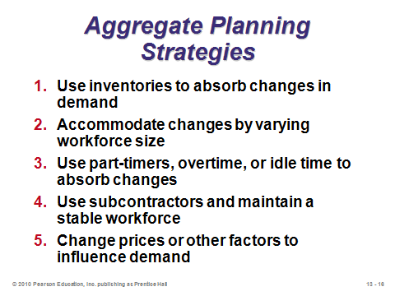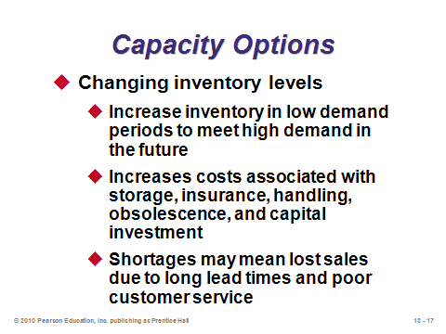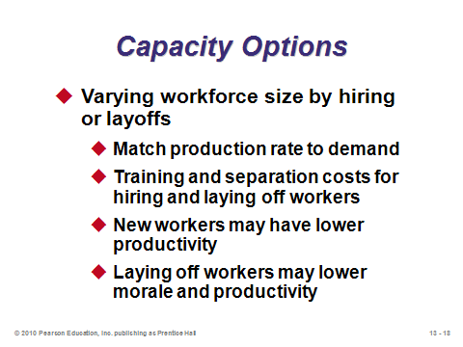

**13-16 13-17 13-18**

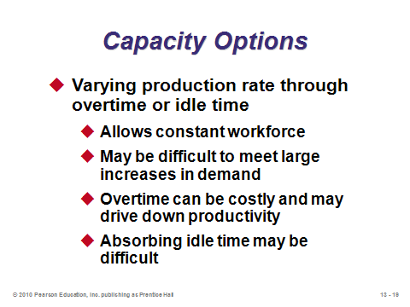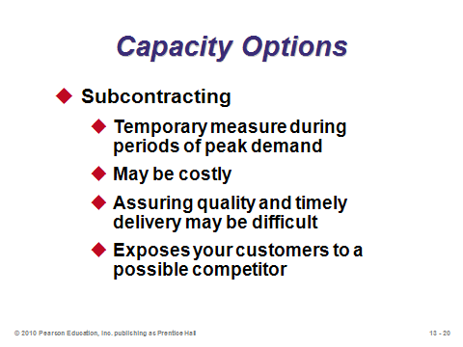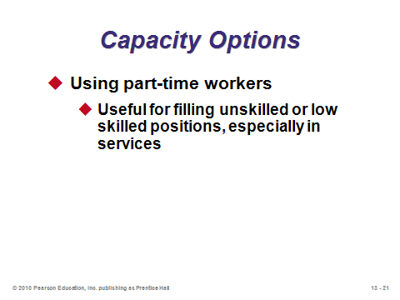

**13-19 13-20 13-21**

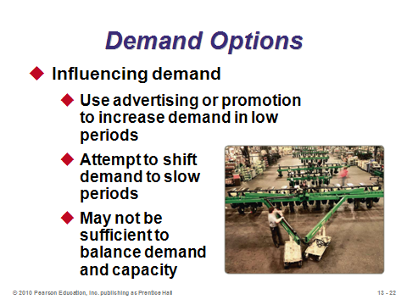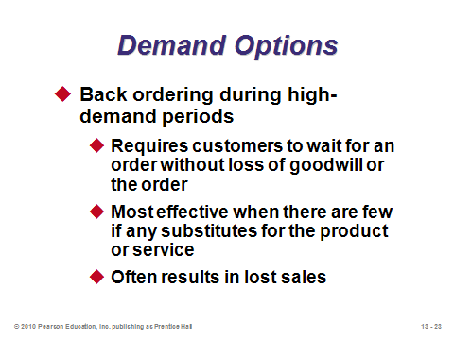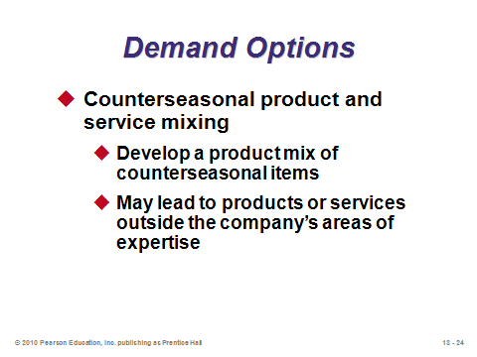

**13-22 13-23 13-24**

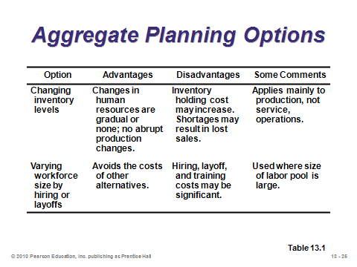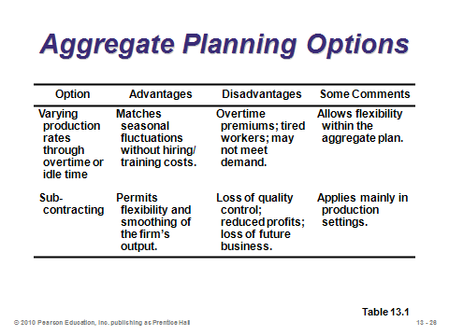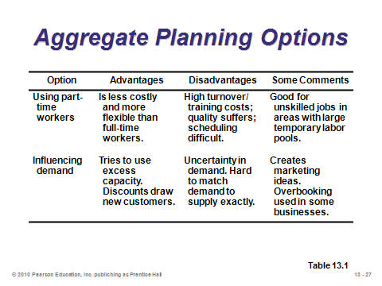

**13-25 13-26 13-27**

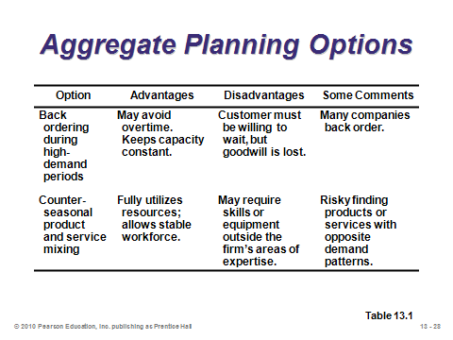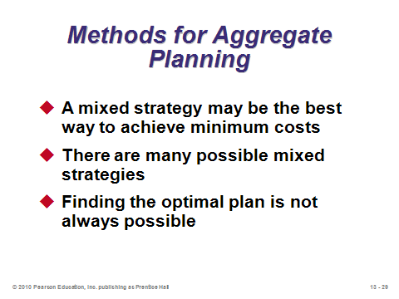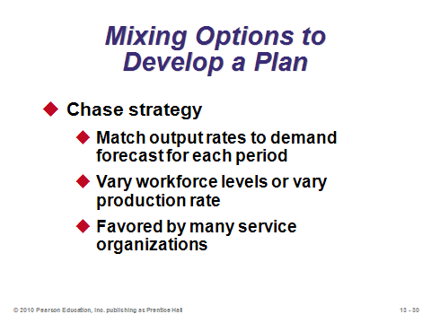

**13-28 13-29 13-30**

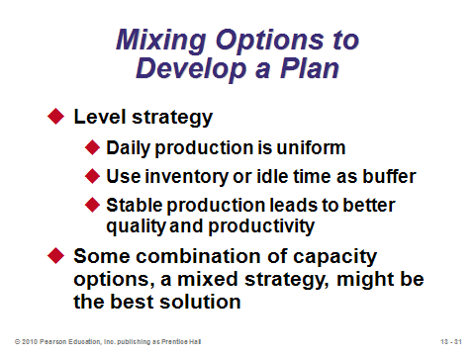

**13-31**

METHODS FOR AGGREGATE PLANNING (13-32 through 13-58)

Graphical Methods (13-32 through 13-49)

Slides 32-33: Graphical methods represent trial-and-error approaches to the aggregate planning problem. Slide 33 identifies the five steps involved. And, actually, Steps 1-4 are required for any of the aggregate planning solution methods.

Slides 34-49: These slides cover continuing Examples 1-4 from the text. Slide 34 presents the demand data for the examples. Note that the daily demand is based on the number of production days per month, which varies for this firm. Slide 35 graphs the average forecasted monthly demand per day as compared to the average daily demand overall of 50 units. The ensuing three examples present three different strategies for meeting the forecasted demand. Slides 36-39 present the raw data along with Example 2—a level strategy with constant workforce. This strategy builds anticipatory inventory in the first few months to be drawn down in later months. The only costs incurred are regular labor and inventory costs. Slides 40-44 present Example 3—a level strategy to cover the lowest-demand period along with subcontracting for all other months. The only costs incurred are regular labor (lower than Example 2) and subcontracting. Slides 45-48 present Example 4—a chase strategy via hiring and layoffs. The costs incurred in this plan are regular labor, hiring, and layoff costs. Slide 49 summarizes the costs of the three plans. In this problem, the subcontracting option was the best among the three options, although that would certainly not always be the case.

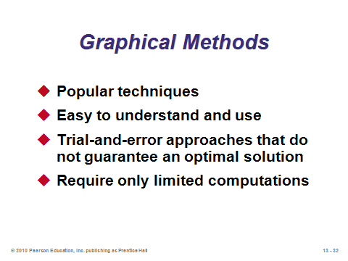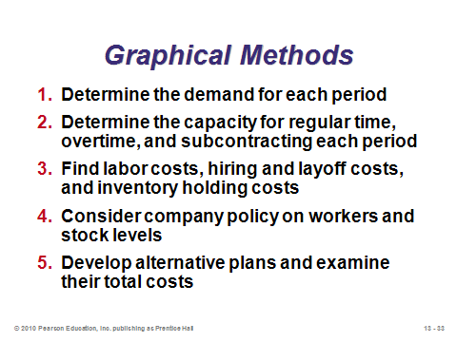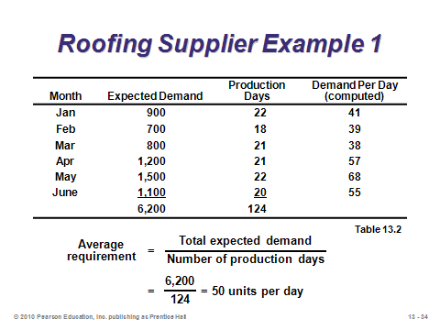

**13-32 13-33 13-34**

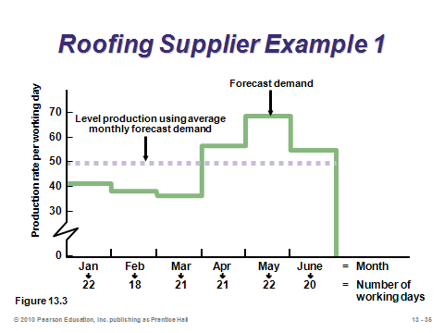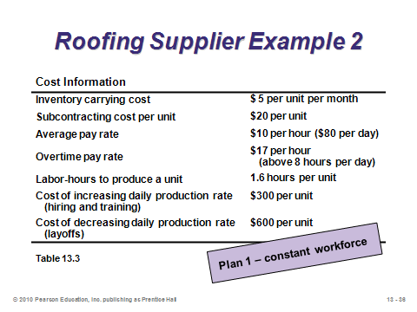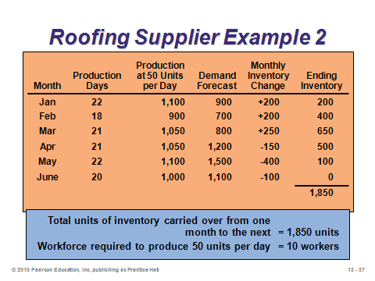

**13-35 13-36 13-37**

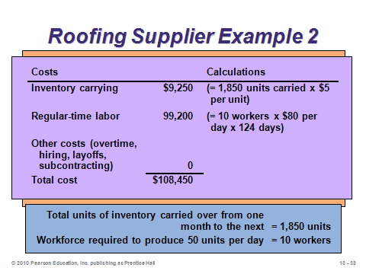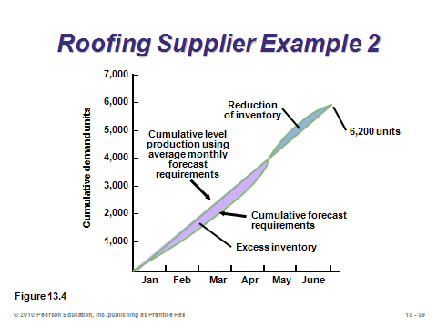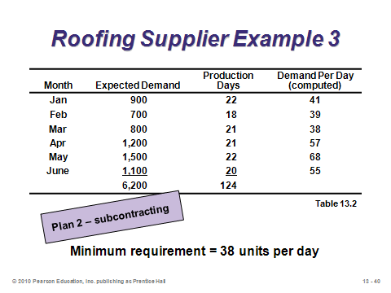

**13-38 13-39 13-40**

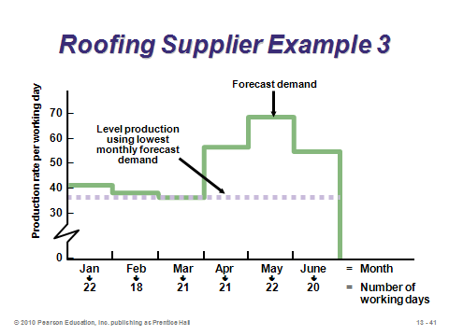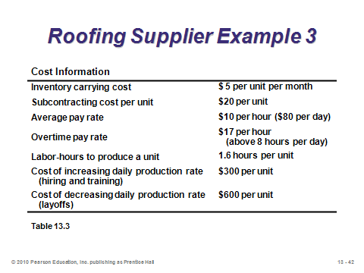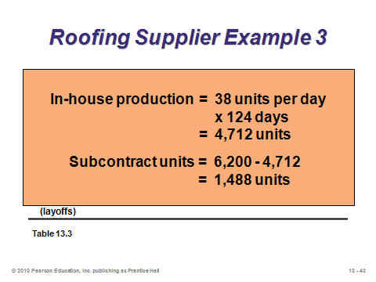

**13-41 13-42 13-43**

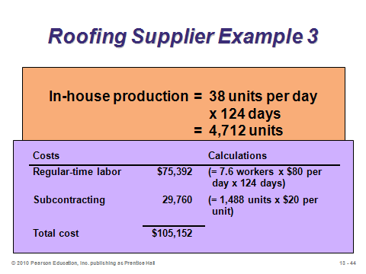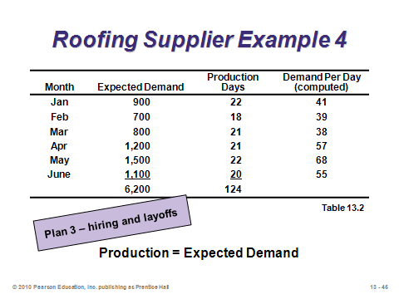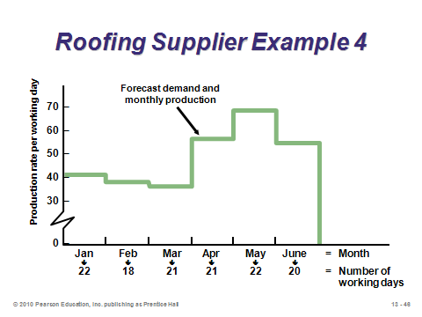

**13-44 13-45 13-46**

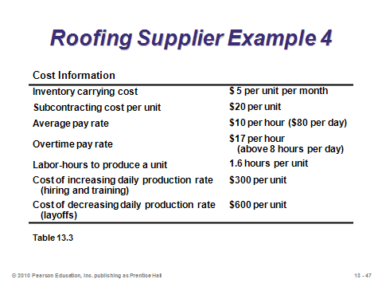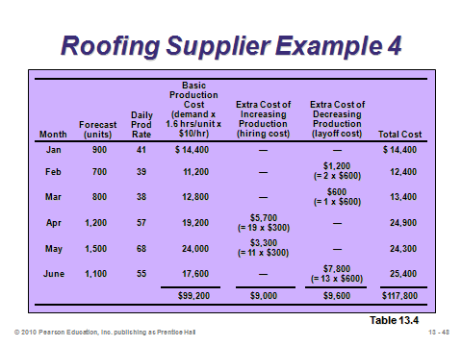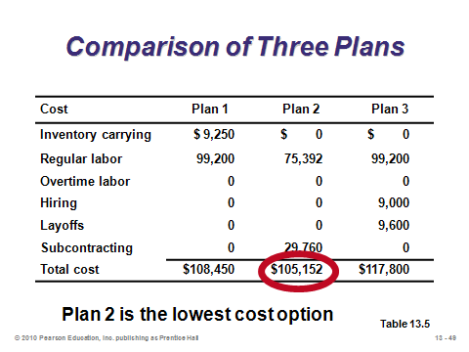

**13-47 13-48 13-49**

Mathematical Approaches (13-50 through 13-58)

Slide 50: This slide identifies the mathematical approaches for generating good strategies that are described in the text.

Slides 51-54: These slides describe the transportation method of linear programming, which is a special type of linear program that can be solved by hand. It applies to aggregate planning when the options are limited to holding inventory, using overtime, and subcontracting. When hiring and firing decisions are also involved, a general linear program that must be solved on a computer should be used (see Other Supplementary Material below). To set up the transportation table, there should be a row for beginning inventory followed by three rows for each period of analysis and a final row for total demand. There should be a column for each period followed by a dummy column for unused capacity and a final column listing the total available capacity (supply). Slide 51 (Example 5) presents the raw data, while Slides 52-53 describe important points about the transportation method. Note that the solution in Slide 54 is feasible, but not optimal. The firm spent $72 per tire to subcontract in period 1 for demand in period 2; however, 100 units of subcontracting capacity were unused in period 2. Moving 100 units of subcontracting from period 1 to period 2 would save $2 per tire or $200 in total holding costs.

Slide 55: The idea behind the management coefficients model is quite different. We assume that previous decisions were good ones and so we create a regression model that relates certain input variables such as demand and labor to past aggregate planning decisions. Future decisions can be based on the resulting regression equations. This minimizes inconsistencies in future decision making.

Slide 56: Two other models are mentioned in this slide. One of the most important original foundational operations management models was the famous HMMS rule, developed by Holt, Modigliani, Muth, and Simon. This model handles quadratic cost curves, which in some situations may be more realistic than linear cost models. Computer simulation, on the other hand, represents a high-volume trial-and-error method, searching for the best alternative among many possibilities. The main downside of simulation that that optimal solutions are not guaranteed.

Slides 57-58: These slides reproduce Table 13.6 from the text, comparing aggregate planning techniques.

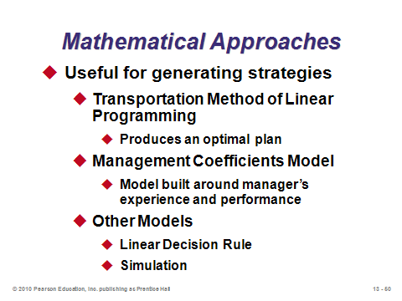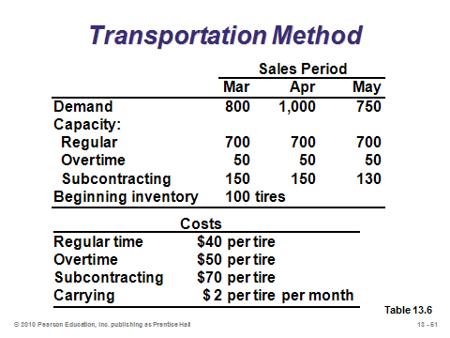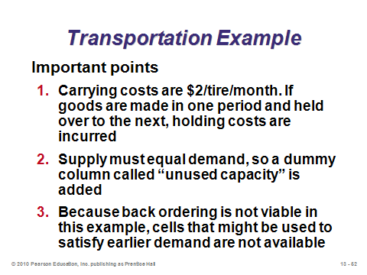

**13-50 13-51 13-52**

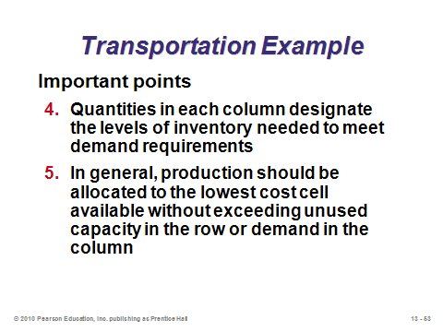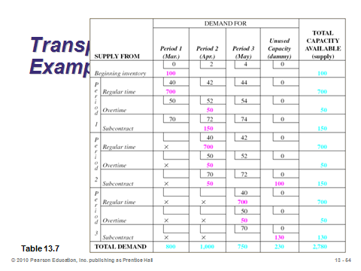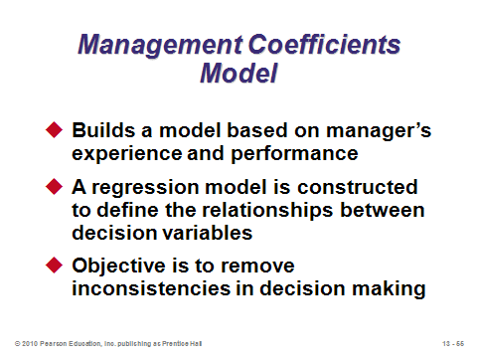

**13-53 13-54 13-55**

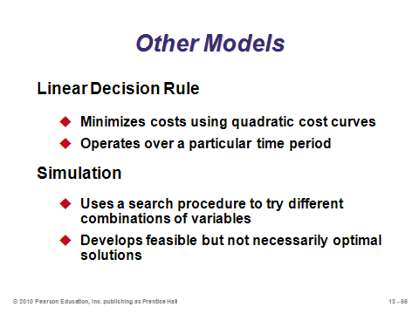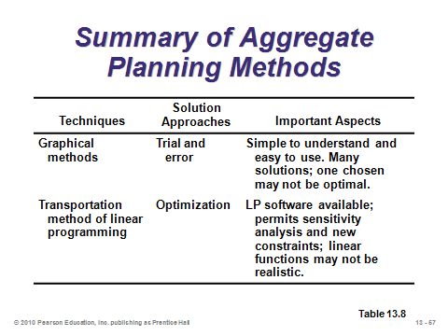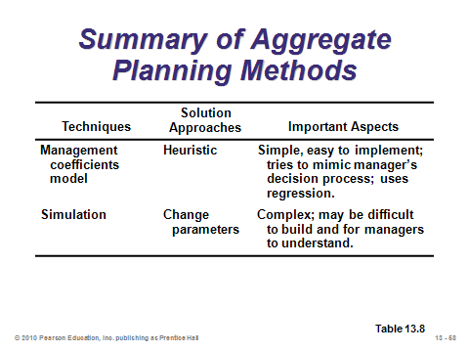

**13-56 13-57 13-58**

AGGREGATE PLANNING IN SERVICES (13-59 through 13-63)

Slide 59: Aggregate planning techniques apply equally as well in services as in manufacturing, but services often implement more demand management strategies. As the control of labor cost is critical in service firms, this slide identifies four successful techniques for doing that.

Slides 60-63: Five different service scenarios are described in these slides. Slide 60: For restaurants, some amounts of anticipatory inventory can be produced during slack periods (rapid inventory perishability is an important consideration), but most demand changes are accommodated by labor capacity changes. Hospitals may have floating staff positions capable of filling in for the very uncertain demand fluctuations in different departments. Slide 61: For chains of small service firms such as funeral homes, oil change outlets, photocopy centers, and tire centers, central planning may be appropriate if the central office can influence demand via special promotions. “Miscellaneous services” include businesses such as financial, transportation, and many communication and recreation services that provide intangible output. Along with managing demand to minimize the need for extra highly paid professionals during peak periods, these firms need to determine how to fully utilize the professionals during low-demand periods. Slide 62 presents Example 6 from the text. Here the law firm analyzes lawyer requirements under best-case, likely, and worst-case demand scenarios. The example suggests a potential shortage (if business is booming) in lawyers to handle trial work and corporate law. Overtime may be adequate to cover the shortfall, but, eventually, more lawyers may need to be hired. Slide 63: The airline industry is considered by some to represent the “mother of all scheduling problems.” And even if a good schedule is produced that satisfies all constraints and maximizes revenue, weather or mechanical problems can wreak havoc on the system.

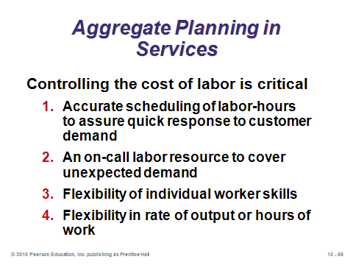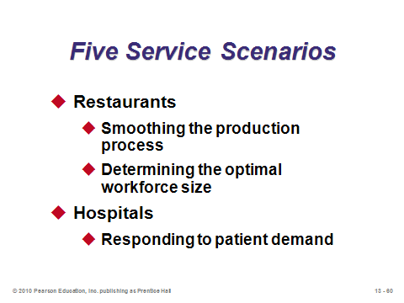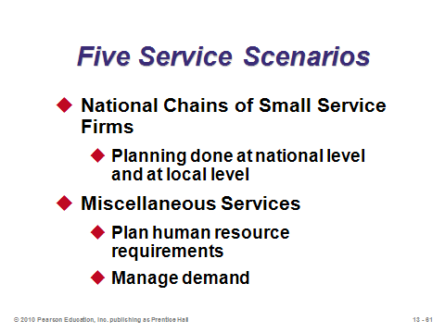

**13-59 13-60 13-61**

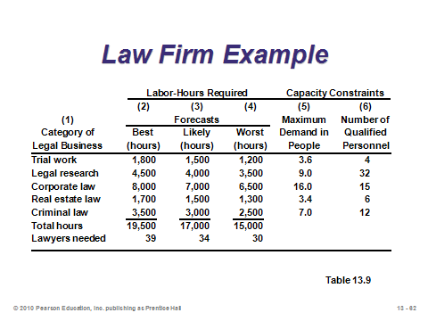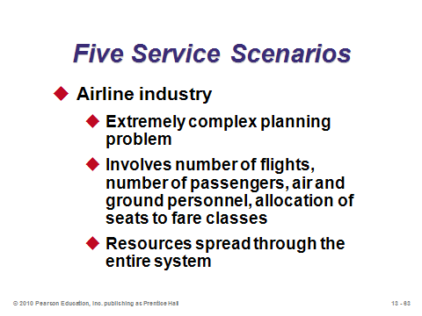

**13-62 13-63**

YIELD MANAGEMENT (13-64 through 13-68)

Slide 64: Yield management (also known as *revenue management*) changes the focus of aggregate planning from capacity management to demand management. Successful yield management implementations have generated millions of dollars of additional revenue for some companies. On the other hand, active yield management programs can drive consumers crazy as they may always feel, for example, that someone else on the airplane must be receiving the same service for a lower price. With yield management, companies keep raising and lowering prices in an attempt to extract as much money from customers as possible while simultaneously trying to fill every seat on the airplane, room in the hotel, or seat in the rock concert. Organizations with *perishable inventory* (airlines, hotels, car rental agencies, cruise lines, etc.) have the shared characteristics identified in Slide 64 that make yield management of interest to them.

Slides 65-66: These illustrate Example 7 from the text. Slide 65 (Figure 13.5) shows the current demand curve as it relates to the current pricing scheme of charging $150 for every room. Because the hotel does not price discriminate based on willingness to pay, potential revenue is lost. Slide 66 (Figure 13.6) shows how additional revenue can be extracted by charging two different price levels.

Slide 67: This slide (Figure 13.7) separates firms into level of predictability of use and variability of price. The industries in Quadrant 2 are traditionally associated with yield management. Nevertheless, with enough imagination, firms in the other quadrants can implement certain yield management techniques. Instructors could insert a short class discussion here by having students try to identify good yield management techniques for the industries listed.

Slide 68: Firms need to manage the three issues identified in this slide to make yield management work. The third issue, “changes in demand,” has at least three components. First, the firm must be able to handle the increased demand with its available resources. Second, customer service must be able to address consumer concerns that arise when the pricing structure may not seem logical and fair to all customers. Third, the firm must deal with any overbooking occurrences arising from an imperfect forecast.

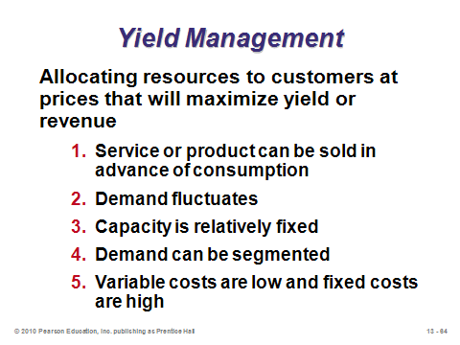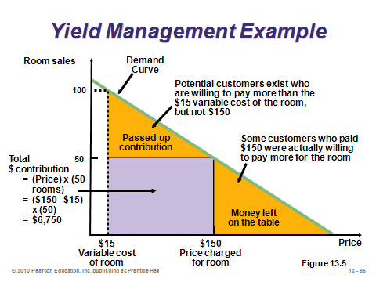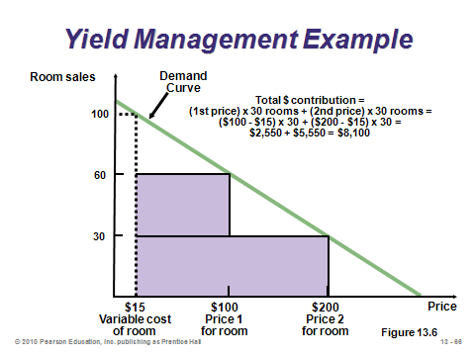

**13-64 13-65 13-66**

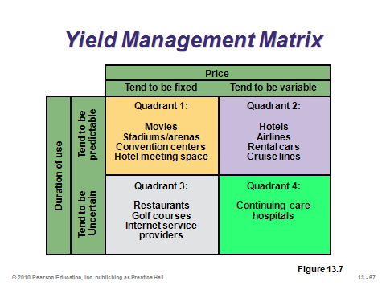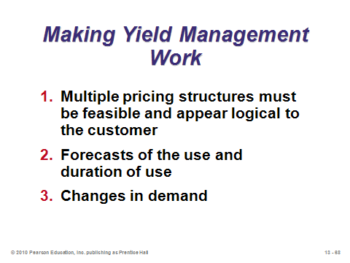

**13-67 13-68**

**Additional Assignment Ideas**

1. An Excel spreadsheet can be developed that finds the optimal aggregate plan via linear programming. (See Other Supplementary Material below.) If the students are learning linear programming in the course (Module B), a good exercise would be to have them try to create such a spreadsheet. Otherwise, instructors can create the spreadsheet themselves and make it available to students who needn’t have any knowledge of linear programming to run the application. Then, various assignments could be developed to have students find the *optimal* solution and possibly compare it to pure chase or level strategies. Another twist could be to use demand option tools to change the pattern of demand, which impacts the aggregate plan. Examples can be created that show that off-season promotions may actually increase overall profit as compared to peak-season promotions, even if the peak-season promotions increase total demand (revenue) by more. This would be due to the expensive impact that very seasonal demand may have on production costs.

2. Instructors could have the students interview someone from the human resources department of a company to inquire about their procedures and costs for hiring (especially temporary) workers, laying off workers, and training new front-line employees. A write-up could describe these procedures and costs in detail.

**Additional Case Studies**

Internet Case Study (www.pearsonglobaleditions.com/heizer)

* *Cornell Glass*: Involves setting a production schedule for an auto glass producer.

Harvard Case Studies (http://harvardbusinessonline.hbsp.harvard.edu)

* *MacPherson Refrigeration Ltd.* (#93D-021): Students need to evaluate three aggregate production plans for the company's products.
* *Sport Obermeyer Ltd.* (#695-022): This Asian skiwear company has to match supply with demand for products with uncertain demand and a globally dispersed supply chain.
* *Chaircraft Corp.* (#689-082): Illustrates effective production planning in a multistage process affected by seasonal demand.

Richard Ivey School of Business (http://cases.ivey.uwo.ca/cases/pages/home.aspx)

* *MacPherson Refrigeration Limited* (#9A93D021): Linda Metzler, newly appointed production planning manager, is drafting an aggregate production plan for the company's refrigerators, freezers, and air conditioners for the next year. She has considered three plans.

**Internet Resources**

|  |  |
| --- | --- |
| APICS: The Association for Operations Management | www.apics.org |

**Other Supplementary Material**

Game

Available from: Ledet Enterprises, Inc., dba The Manufacturing Game

777 FM 1960 East, Suite 226

Humble, TX 77346

(P) 281-812-4148

(F) 281-812-4149

(E) info@mfg-game.com

http://www.manufacturinggame.com/

* *The Manufacturing Game*

Linear Programming in Excel

In Example 5, the text clearly illustrates how to solve the aggregate planning problem by hand when it can be converted into the transportation model of linear programming. A downside of this approach is that hiring and layoff costs based on production change cannot be included. However, Excel can handle the more general linear programming problem with relative ease. Interested instructors can create the spreadsheet and make it available for their students. All the students would need to do is input the parameters and run Solver to find the optimal plan. The spreadsheet shown below is based on the aggregate planning environment covered in the book.

**INPUT SECTION:**

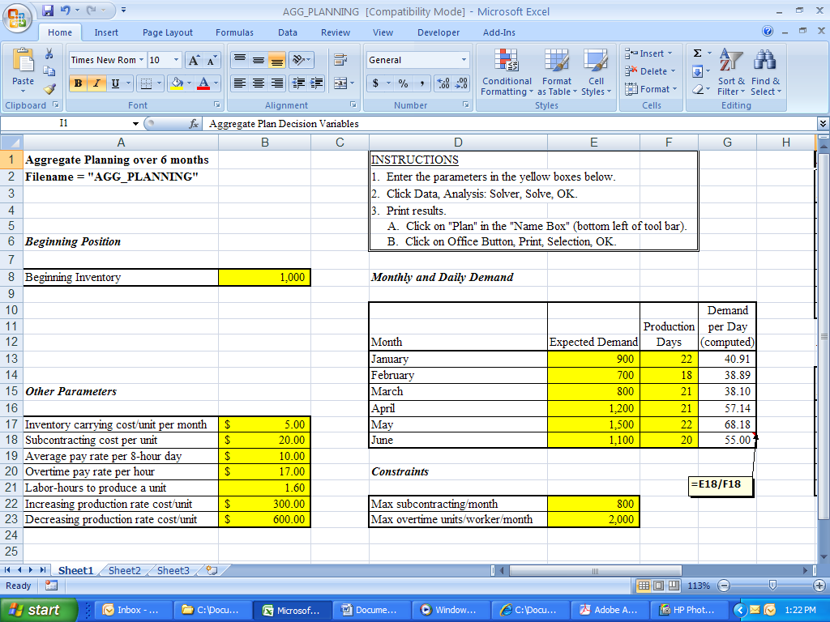

**OUTPUT SECTION:**

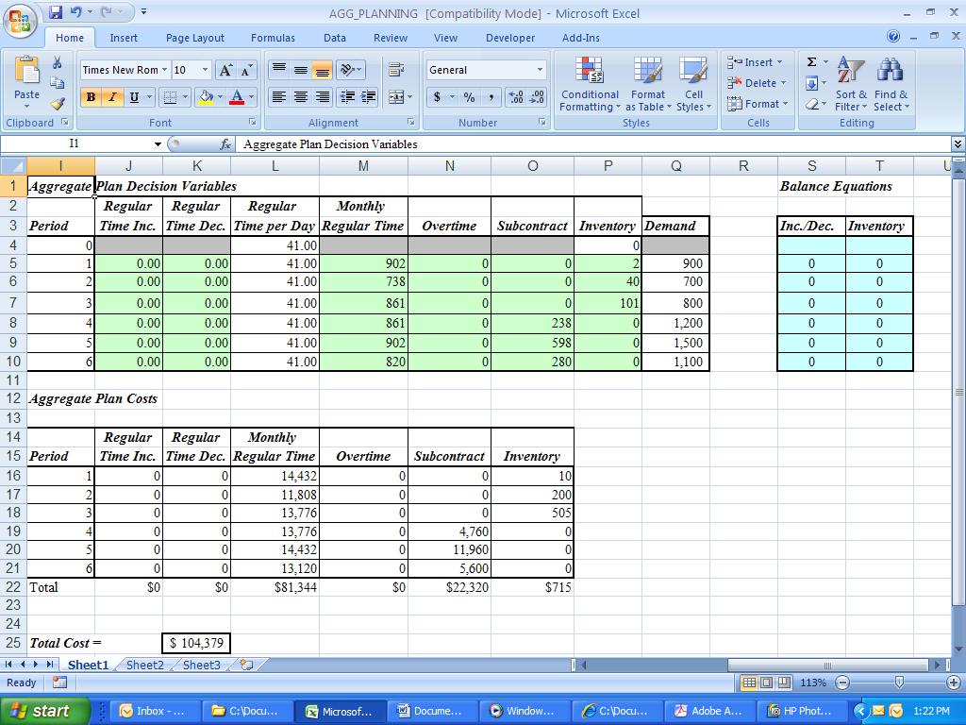

**FORMULAS FOR THE BALANCE EQUATIONS:**

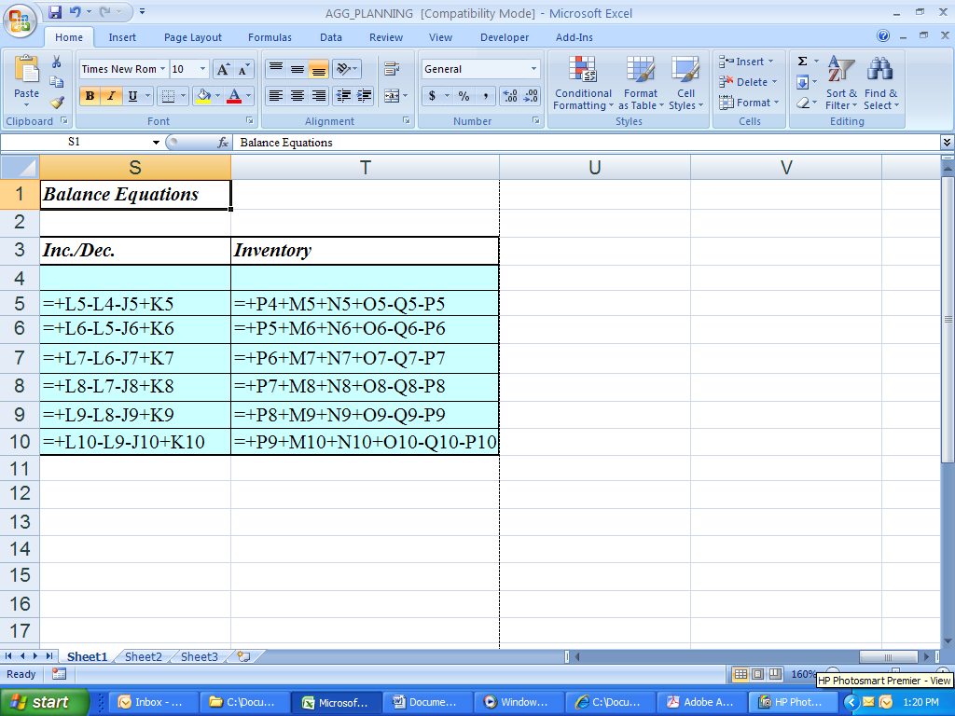

**FORMULAS IN THE OUTPUT SECTION:**

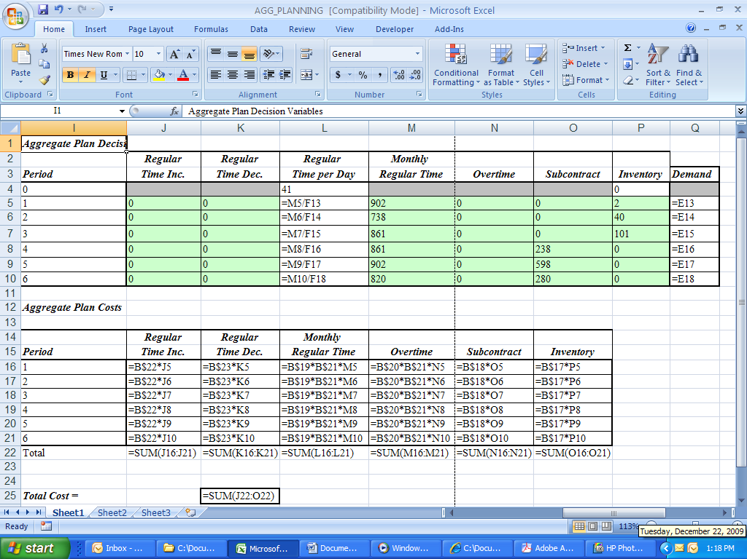

**SOLVER DIALOG BOX:**

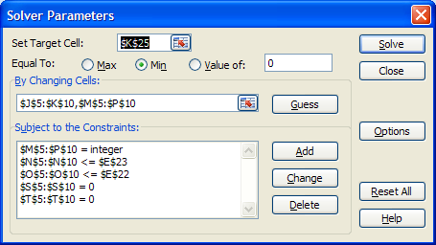

**SOLVER OPTIONS BOX:**

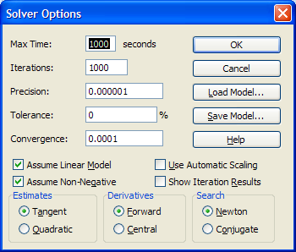

Notes: The regular time increase and decrease values are probably the trickiest feature. We want to avoid using IF statements to ensure that the formulation remains a linear integer program. The balance equations for “*Inc/Dec*” provide the necessary logic. The “*Inventory”* balance equations ensure that demand is met in some way in each month, and they create positive inventory when available inventory exceeds demand. Finally, there is a rounding issue with the way in which the text has formulated the problem. The Excel program displayed here assumes that the costs for increasing and decreasing production are *proportional*, allowing, for example, half the cost to be incurred if a one-half day change in production occurs (i.e., the daily production rate numbers are *not* rounded in the spreadsheet).